Software Design Specifications
For
Professor Rating Based on Course Outcome Feedback System
Version 1.0

Prepared by– Group 50

Sreeja Rao Surabhi | SE23UCSE202 | Frontend Developer
Srujana Yampati | SE23UCSE189 | Frontend Developer
P. Rishith | SE23UCSE200 | Backend Developer
S. Koushik | SE23UCSE234 | Frontend Developer
G. Vijay | SE23UCSE193 | API Developer
B. Ganesh | SE23UCSE033 | Backend Developer

Document Information
Title: | Software Design Specification – Professor Rating and Course Outcome Feedback System
Project Manager: | P. Rishith (SE23UCSE200)
Document Version: | 1.0
Version Date: | March 2026
Prepared By: | GROUP 50
Preparation Date: | March 2026

Version History
Ver. | Date | Revised By | Description
V1.0 | 5-4-2026 | Ganesh, Vijay | Initial SDS,Introduction and Design Overview
v1.1 | 7-4-2026 | Sreeja, Srujana | logical view , data view and exception handling added
V1.2 | 8-4-2026 | Koushik | configurable parameters
v1.3 | 9-4-2026 | Sreeja, srujana, rishith | the document improvements made , new model diagrams finalized

Table of Contents

1 INTRODUCTION............................................................................................................................................................ |  | 4
1.1 | PURPOSE ...................................................................................................................................................................... | 4
1.2 | SCOPE .......................................................................................................................................................................... | 4
1.3 | DEFINITIONS, ACRONYMS, AND ABBREVIATIONS ........................................................................................................ | 4
1.4 | REFERENCES ................................................................................................................................................................ | 4

2 | USE CASE VIEW ............................................................................................................................................................ |  | 4
 | 2.1 | USE CASE ..................................................................................................................................................................... | 4
3 | DESIGN OVERVIEW..................................................................................................................................................... |  | 4
 | 3.1 | DESIGN GOALS AND CONSTRAINTS ............................................................................................................................. | 5
 | 3.2 | DESIGN ASSUMPTIONS ................................................................................................................................................. | 5
 | 3.3 | SIGNIFICANT DESIGN PACKAGES ................................................................................................................................. | 5
 | 3.4 | DEPENDENT EXTERNAL INTERFACES ........................................................................................................................... | 5
 | 3.5 | IMPLEMENTED APPLICATION EXTERNAL INTERFACES ................................................................................................. | 5
4 | LOGICAL VIEW............................................................................................................................................................. |  | 5
 | 4.1 | DESIGN MODEL ............................................................................................................................................................ | 6
 | 4.2 | USE CASE REALIZATION .............................................................................................................................................. | 6
5 | DATA VIEW.................................................................................................................................................................... |  | 6
 | 5.1 | DOMAIN MODEL .......................................................................................................................................................... | 6
 | 5.2 | D ATA MODEL (PERSISTENT DATA VIEW)...................................................................................................................... | 6
 | 5.2.1 Data Dictionary.................................................................................................................................................... |  | 6
6 | EXCEPTION HANDLING ............................................................................................................................................. |  | 6
7 | CONFIGURABLE PARAMETERS .............................................................................................................................. |  | 6
8 | QUALITY OF SERVICE................................................................................................................................................ |  | 7
 | 8.1 | AVAILABILITY.............................................................................................................................................................. | 7
 | 8.2 | SECURITY AND AUTHORIZATION ................................................................................................................................. | 7
 | 8.3 | LOAD AND PERFORMANCE IMPLICATIONS ................................................................................................................... | 7
 | 8.4 | MONITORING AND CONTROL ....................................................................................................................................... | 7

1 Introduction

This Software Design Specification (SDS) describes the detailed software design for the Professor Rating based on Course Outcome Feedback System which is a full-stack web application enabling anonymous student feedback on professors and Course Outcomes (CO1–CO5). This document translates the requirements captured in the SRS v1.2 and SOW into a complete architectural, component-level, and data design ready for implementation.

1.1 Purpose

This SDS is the primary technical reference document for the implementation, verification, and maintenance of the system. It provides:
- A description of the system architecture and component decomposition
- Detailed class and interface designs for each module
- Use case realization through sequence and interaction diagrams
- A persistent data model with a complete data dictionary
- A requirements traceability matrix linking every SRS requirement to a design component
- Quality-of-service and exception handling strategies

1.2 Scope

This SDS covers the complete design of the full-stack web application including the React (frontend), the Node.js, Express 4 REST API (backend), and the MongoDB. It also covers the attendance eligibility validation subsystem, anonymous feedback storage, duplicate-submission prevention, and role-based access control for three user roles: Student, Professor, and Administrator.

1.3 Definitions, Acronyms, and Abbreviations

Term
  Definition
API | Application Programming Interface used for communication between frontend and backend.
CO | Course Outcome - a measurable learning objective defined for a course.
CRUD | Create, Read, Update, Delete operations performed on database records
DB | Database used to store system information
Mongo DB | NoSQL database used for storing application data
Node.js | JavaScript runtime used to implement backend services
React | JavaScript framework used for building the frontend interface
REST API | API architecture used for communication between client and server
SRS | Software Requirements Specification
UI | User Interface used by students to interact with the system

  - References

- SRS v1.2 – Software Requirements Specification for Professor Rating Based on Course Outcome Feedback System
- Statement of Work – Professor Rating and Course Outcome Feedback Website
- IEEE Std 1016-2009 – IEEE Standard for Information Technology
- React 18 Documentation – https://react.dev
- Node.js 18 Documentation – https://nodejs.org/en/docs
- Express 4 Documentation – https://expressjs.com
- Mongoose 7 Documentation – https://mongoosejs.com/docs
- MongoDB 6 Documentation – https://www.mongodb.com/docs
- JSON Web Tokens Specification – RFC 7519 / https://jwt.io

2 Use Case View

This section describes the functional behaviour of the system using use cases. The use cases represent key interactions between users (students, professors, and administrators) and the system.
These use cases are derived from the functional requirements specified in the SRS and form the basis for the system design.

2.1 Use Case: Submit Feedback

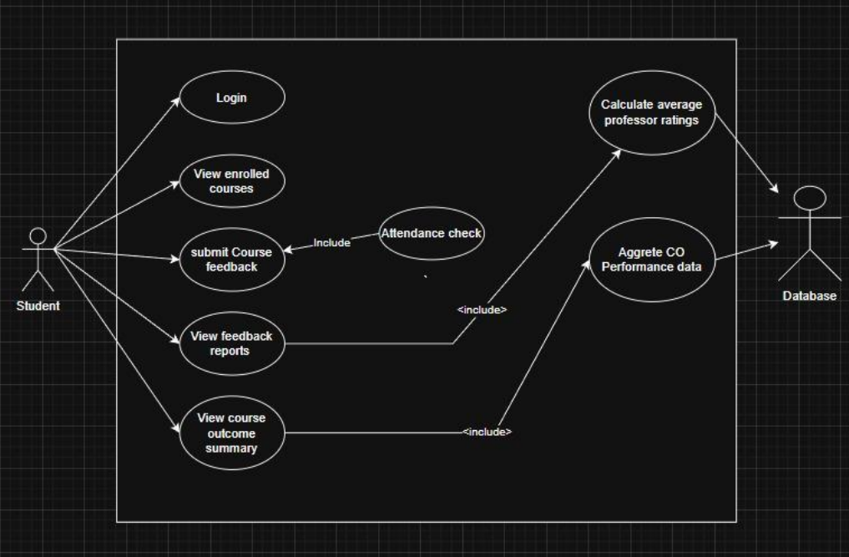
Purpose: This use case diagram describes how students interact with the Professor Rating Based on Course Outcome Feedback System to submit course feedback, view
Reports, and access course outcome summaries. The system validates student
Eligibility through an attendance check before allowing feedback submission

Requirements Traceability: F1, F2, F3, F4, F5, F6, F7, F8, F9, F10

Priority: High

Preconditions:
• The student must be registered in the university system.
• The student must have valid login credentials.
• Course enrolment and professor information must exist in the system database
• Attendance data must be available for validation.

Post conditions:
• Student feedback is successfully submitted and stored anonymously.
• The system generates updated feedback reports and course outcome
Summaries.
• Dashboard analytics are updated with the latest feedback information.

Actors:
• Student
• Database

Flow of Events:
1. Basic Flow

1. The student accesses the feedback platform.
2. The system displays the login interface.
3. The student enters login credentials.
4. The system authenticates the student and displays the student dashboard.
5. The student views the list of enrolled courses.
6. The student selects a course and chooses to submit course feedback.
7. The system performs an attendance check for the selected course.
8. If the attendance requirement (≥75%) is satisfied, the system displays the
Feedback form.
9. The student fills in professor ratings, course outcome evaluations, and
Optional comments.
10. The student submits the feedback form.
11. The system stores the feedback anonymously in the database.
12. The system processes feedback data to calculate average professor ratings.
13. The system aggregates Course Outcome performance data.
14. The system prepares dashboard analytics data for reporting.
15. The student may view feedback reports and course outcome summaries

2. Alternative Flow:

1. If the student attempts to submit feedback more than once for the same
Course, the system prevents duplicate submission.
2. The student may choose to only view feedback reports or course outcome
Summaries without submitting new feedback.

3. Exceptions:

1. If attendance is below the required threshold (75%), the system prevents
Feedback submission.
2. If the system cannot retrieve attendance data, the feedback process is
Temporarily blocked.
3. Database errors may prevent feedback storage.

Includes:
• Attendance Check
• Calculate Average Professor Ratings
• Aggregate CO Performance Data
• Prepare Dashboard Analytics Data

Notes/Issues: Student identities must not be directly linked to feedback responses to
Ensure anonymity.

2.2 Use Case#2

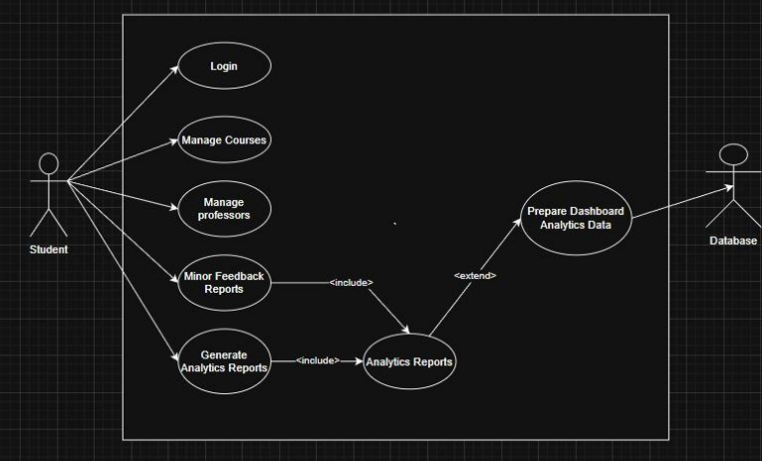

Purpose - This use case describes how the administrator interacts with the Professor
Rating Based on Course Outcome Feedback System to manage academic data such
as courses and professors, monitor feedback reports, and generate analytical reports
for evaluations.

Requirements Traceability - F14, F15, F16

Priority – Medium

Preconditions –
• The administrator must be registered in the system.
• The administrator must log into the system using valid credentials.
• Course, professor, and feedback data must exist in the system database.

Post conditions –
• Course and professor information may be added, updated, or removed.
• Feedback reports are generated and available for administrative monitoring.
• Analytics reports and dashboard data are prepared for system insights.

Actors –
• Administrator
• Database

Flow of Events

1. Basic Flow
1. The administrator accesses the system login page.
2. The administrator enters login credentials.
3. The system authenticates the administrator.
4. The system displays the administrative dashboard.
5. The administrator selects a management function.
6. The administrator may manage course information (add, update, or delete
courses).
7. The administrator may manage professor records and course assignments.
8. The administrator may monitor feedback reports generated from student
evaluations.
9. The system generates analytics reports based on stored feedback data.
10.The system prepares dashboard analytics data for visualization.
11.The administrator views the generated reports and analytics information.

2. Alternative Flow
1. The administrator may directly generate analytics reports without modifying
course or professor data.
2. The administrator may choose to only view feedback reports.
3. Exceptions
1. Invalid administrator login credentials prevent access to the system.
2. Database connectivity failure prevents retrieval or modification of system
data.
3. Missing feedback data results in empty analytics reports.
Includes –
• Analytics Reports
• Generate Analytics Reports

Notes/Issues –
•Administrative access must be restricted to authorized users only.
•All modifications to course and professor records should be logged to maintain system accountability.

- Design Overview

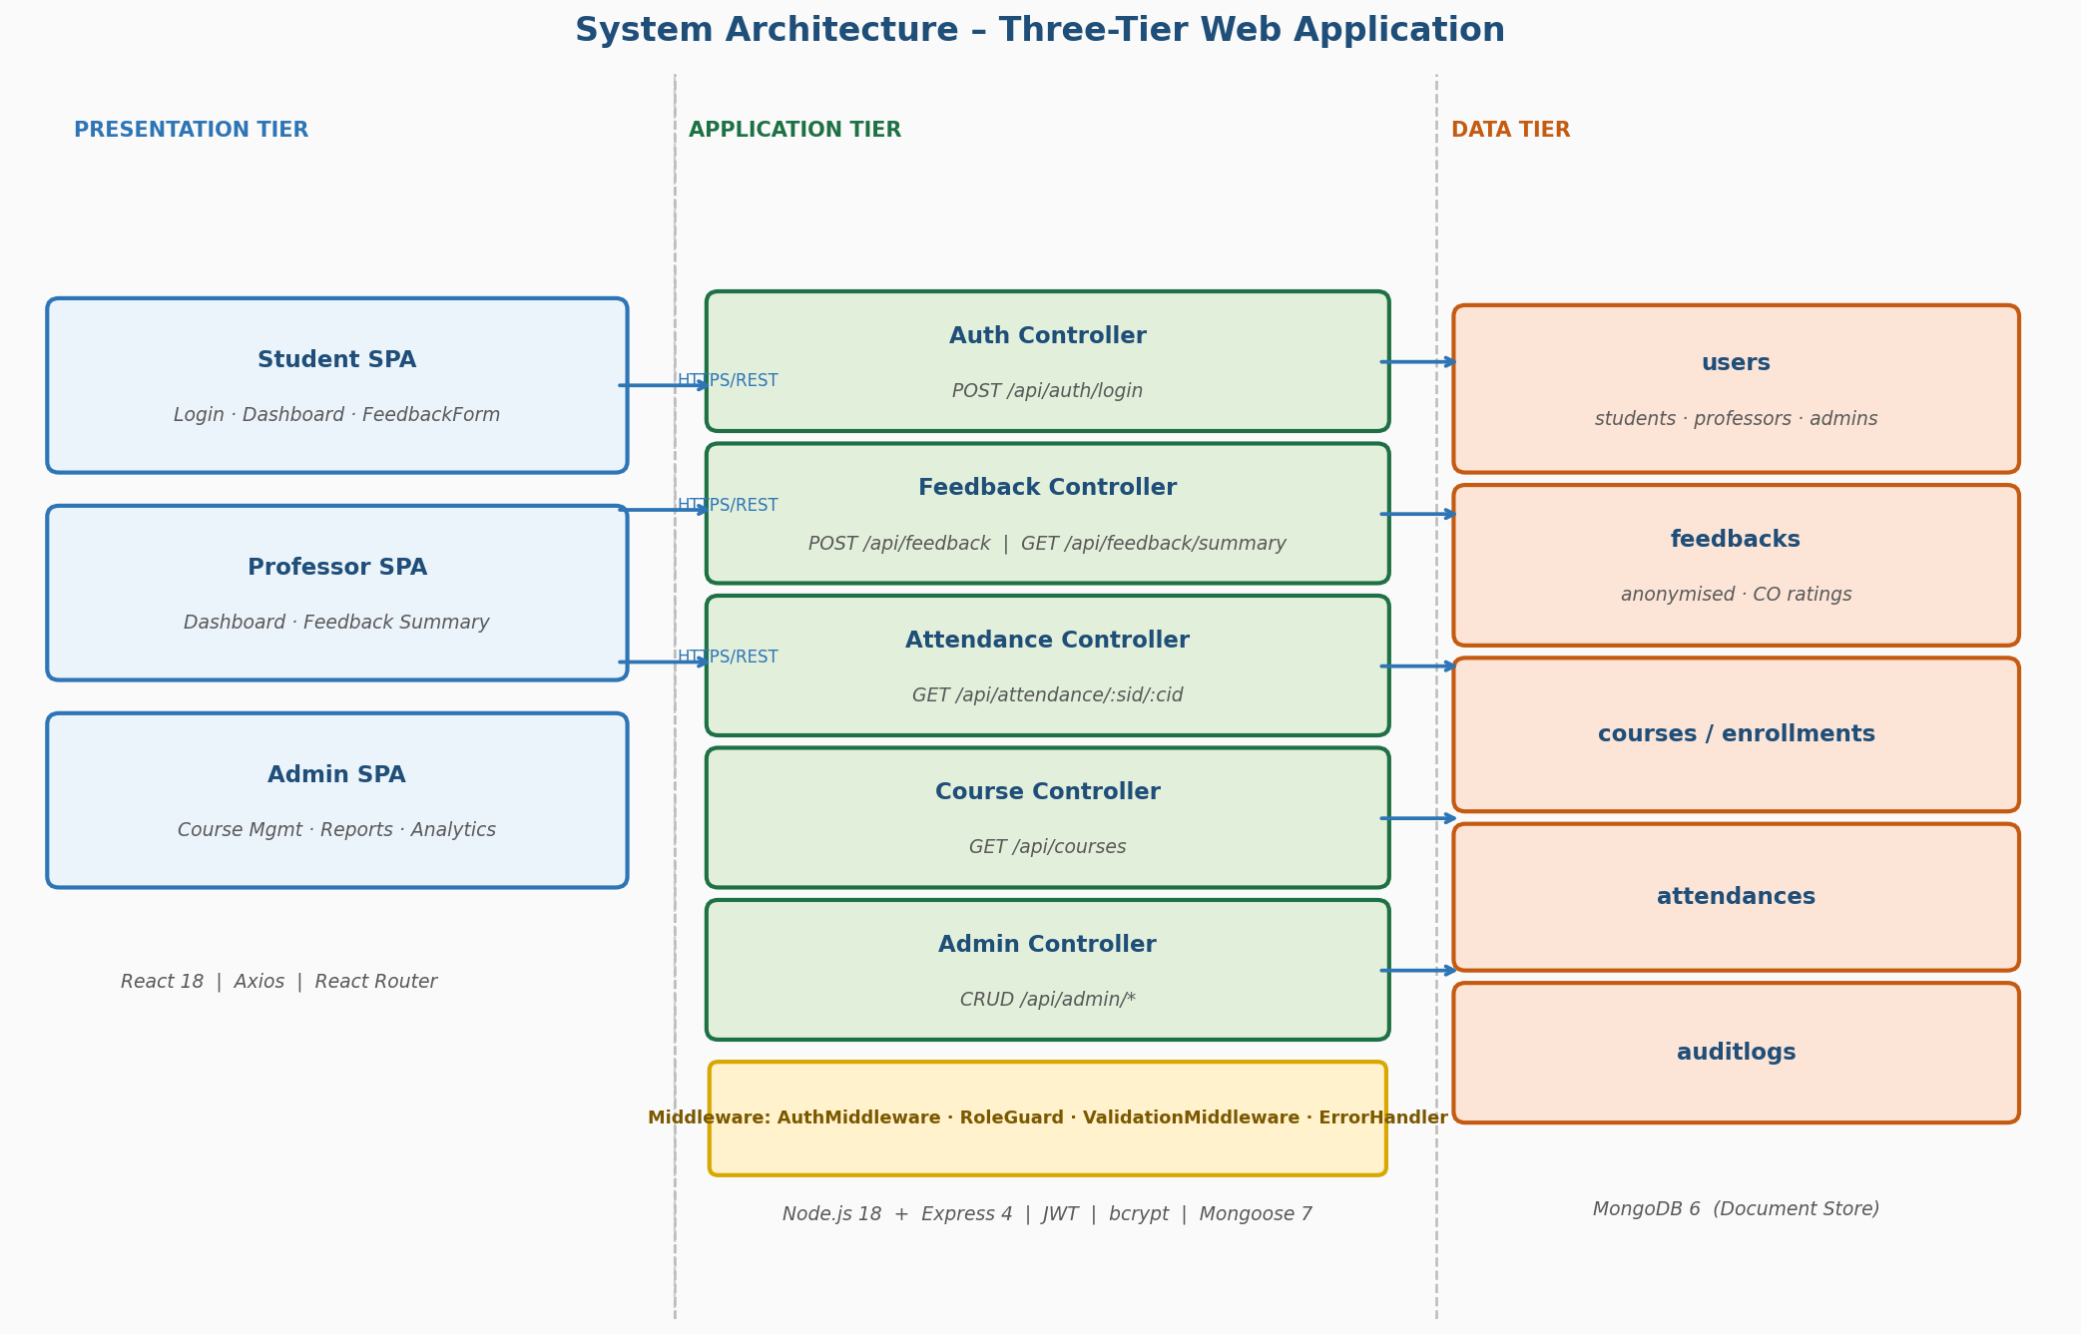

The Professor rating based on Course Outcome Feedback System is designed as a three-tier, web application. The Presentation Tier is a React 18 SPA served to the browser. The Application Tier is a Node.js + Express 4 REST API. The Data Tier is a MongoDB 6 document store accessed via Mongoose 7. This separation enables independent scaling and deployment of each tier.

3.1 Design Goals and Constraints

Design Goals
- Anonymity: Student identity must be cryptographically de-identified before any feedback document is written to the database.
- Integrity: Attendance validation (≥ 75%) and duplicate-submission prevention must be enforced server-side, not only in the frontend.
- Separation of Concerns: The three tiers communicate only through defined REST API contracts; no tier accesses another tier's internals.
- Usability: The React SPA must be responsive for desktop and mobile browsers; all forms must validate locally before submitting.
- Security: All sensitive parameters (JWT secret, DB URI, anonymisation salt) are stored in environment variables and never committed to source control.

Design Constraints
- Technology Stack: React (frontend), Node.js + Express (backend), MongoDB (database) – fixed as per SRS Section 1.2 and SOW.
- Attendance Gate: Feedback is permitted only when attendance ≥ 75%. Enforced in EligibilityChecker called from FeedbackController.
- Single Submission Rule: A unique compound index on {hashedSubmitterId, courseId} in the feedbacks collection enforces one submission per student per course at the database level.
- Mandatory Form Completion: All CO ratings and professor rating fields are required; backend rejects incomplete payloads with HTTP 422.

3.2 Design Assumptions

- University student, professor, course, and attendance data are available and can be seeded into MongoDB before system launch.
- All users have access to a modern evergreen web browser (Chrome, Firefox, Edge) and a stable internet connection.
- The deployment environment supports Node.js 18+ and MongoDB 6.0+.
- HTTPS/TLS is terminated at the reverse proxy (e.g., Nginx) level; the Node.js process communicates internally over HTTP.
- A username/password authentication flow backed by encryption

3.3 Significant Design Packages

Package / Directory | Responsibility | Technology
client/src/pages | Page-level React components: LoginPage, StudentDashboard, FeedbackForm, ProfessorDashboard, AdminDashboard | React 18
client/src/components | Reusable UI: RatingSlider, COCard, NavBar, AttendanceGate (HOC), ConfirmationPage | React 18
client/src/services | Axios-based API client wrappers: authService, feedbackService, attendanceService, courseService | Axios 1.x
client/src/context | React Context for JWT token and user role state | React Context API
server/routes | Express Router definitions mapping HTTP verbs + paths to controllers | Express 4
server/controllers | Business logic entry points: authController, feedbackController, attendanceController, courseController, adminController | Node.js 18
server/middleware | authMiddleware (JWT verify), roleGuard, validationMiddleware (express-validator), errorHandler | express-jwt, express-validator
server/models | Mongoose schema definitions: User, Course, Enrollment, Attendance, Feedback, AuditLog | Mongoose 7
server/services | Service classes implementing business rules: AttendanceService, FeedbackService, AdminService, AuditLogger | Node.js 18
server/utils | AnonymisationUtil (HMAC), DuplicateChecker, FeedbackAggregator, Logger (Winston) | Node.js crypto, Winston

3.4 Dependent External Interfaces

External Application / Interface | Module Using It | Functionality / Description
MongoDB (Atlas or local) | server/models (Mongoose) | Persistent storage of all collections. Mongoose opens a connection pool via mongoose.connect(MONGODB_URI). All CRUD operations go through Mongoose model methods.
Institutional Attendance DB / API | server/services/AttendanceService | Provides attendance percentage for (studentId, courseId). Pre-seeded into the attendances collection; if a live university API becomes available it is called via Axios.
bcrypt (npm) | server/services/AuthService | Hashes passwords at registration (bcrypt.hash) and verifies at login (bcrypt.compare). Cost factor configurable via BCRYPT_SALT_ROUNDS env var.
jsonwebtoken (npm) | server/middleware/authMiddleware, server/services/AuthService | Signs JWT on login (jwt.sign) and verifies on every protected request (jwt.verify). Secret from JWT_SECRET env var; expiry from JWT_EXPIRES_IN.
Node.js crypto module | server/utils/AnonymisationUtil | Generates HMAC-SHA256 hash of (studentId + courseId + salt) to anonymise the submitter identity before storage.
express-validator (npm) | server/middleware/validationMiddleware | Validates and sanitises incoming request bodies for all POST/PUT endpoints.

3.5 Implemented Application External Interfaces (and SOA web services)

The table below is the complete REST API contract exposed by this application for consumption by the React SPA and any future integrations.
Endpoint | Method | Role Required | Description
/api/auth/login | POST | None | Authenticate user; returns {token, role, name}
/api/courses | GET | Student | Returns enrolled courses with professor info
/api/attendance/:sid/:cid | GET | Student | Returns {attendancePercentage} for eligibility check
/api/feedback | POST | Student | Submit anonymised feedback; enforces eligibility + duplicate check
/api/feedback/summary/:courseId | GET | Professor / Admin | Returns aggregated ratings and CO statistics
/api/professor/courses | GET | Professor | Returns courses assigned to the authenticated professor
/api/admin/courses | GET | Admin | Lists all courses
/api/admin/courses | POST | Admin | Creates a new course; logs to AuditLog
/api/admin/courses/:id | PUT | Admin | Updates course; logs to AuditLog
/api/admin/courses/:id | DELETE | Admin | Removes course; logs to AuditLog
/api/admin/professors | GET | Admin | Lists all professors
/api/admin/professors/:id | PUT | Admin | Updates professor / assigns to course; logs to AuditLog
/api/health | GET | None | Returns server uptime, DB status, Node version
/api/metrics | GET | None | Prometheus-compatible metrics endpoint

4. Logical View

This section describes the detailed software design at the class and module level, supported by a class diagram and use case realization sequence diagrams

4.1 Design Model
The system is designed using a clean structure to keep everything organized:
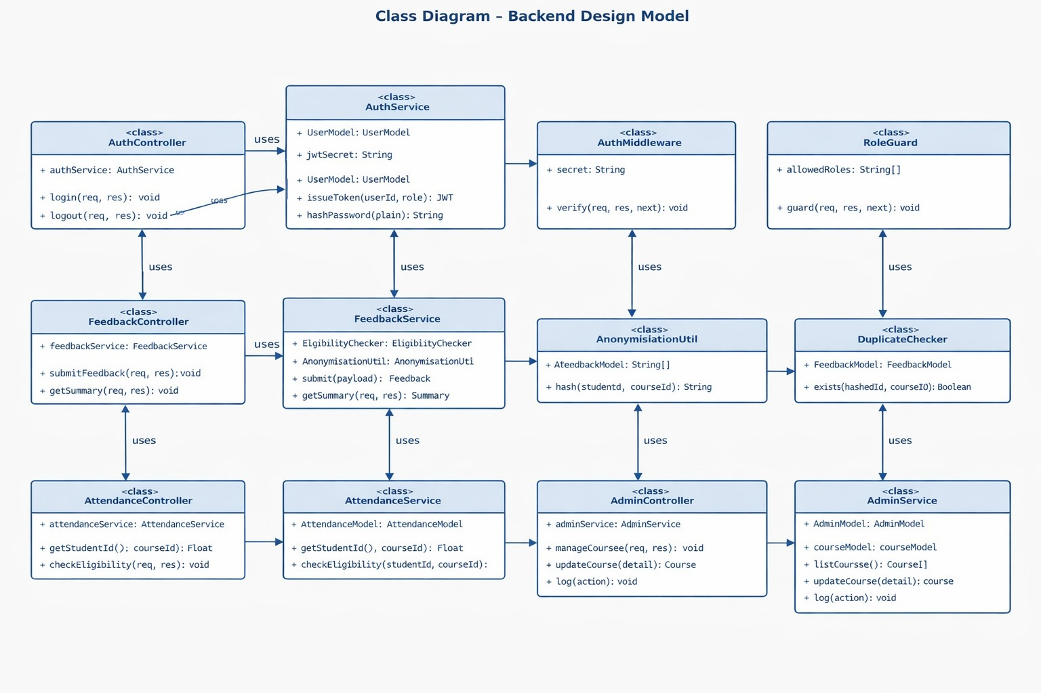

- On the backend, we follow a Model Controller Service pattern, so each part has a clear responsibility.
- On the frontend, we use a component-based architecture (React) to keep the UI modular and reusable.

4.1.1 Important Components and Classes Frontend (React Components)

- FeedbackForm
This handles the feedback form where students give ratings for CO1–CO5 and professor performance. It also checks inputs before submission.

- AttendanceGate
This is a protected wrapper (HOC) that only allows students to submit feedback if they meet the attendance requirement.

- AnalyticsDashboard
This component shows feedback data in charts and graphs for better understanding.

Backend
- FeedbackController
Handles feedback submission requests and connects different services to process the data.

- AdminController
Used by admins to manage courses and professors (add, update, delete).

- AnonymisationUtil
This ensures student identity stays hidden. It uses HMAC-SHA256 with a secret salt to generate a secure ID that cannot be traced back.

- EligibilityChecker
Checks whether the student has at least 75% attendance before allowing feedback submission.

4.2 Use Case Realization

4.2.1 Sequence: Submitting Anonymous Feedback
Here’s how the system works step-by-step when a student submits feedback:
- The student fills out and submits the Feedback Form.
- The frontend sends a request to the backend using Axios (/api/feedback) along with a JWT token.
- The Auth Middleware verifies the token. If valid, it extracts the student ID.
- The Feedback Controller asks the Attendance Service for the student’s attendance.
- The Attendance Service checks the database:
  - If attendance is ≥ 75%, it allows the process to continue.
- The Anonymisation Utility creates a secure hashed ID using student and course data.
- The MongoDB database:
  - Checks if feedback already exists for that hashed ID and course (to prevent duplicates).
  - If not, it stores the feedback.
- The backend returns a success response.
- The frontend shows a confirmation page to the student.

5 Data View

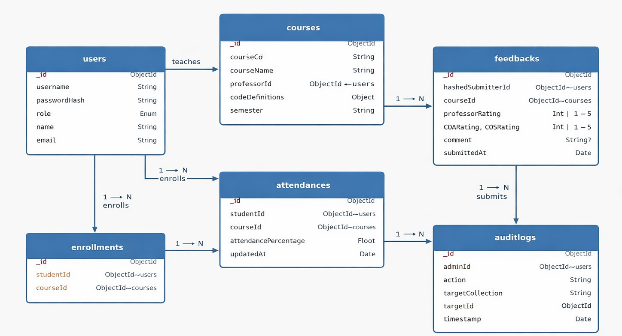

5.1 Domain Model

The system mainly uses these five entities:
- User: Stores login details and roles (Student, Professor, Admin)
- Course:Contains course info and assigned professor
- Attendance : Stores student attendance for each course
- Feedback : Stores anonymous feedback data
- AuditLog : Keeps track of admin actions for transparency

5.2 Data Model (persistent data view)

5.2.1 Data Dictionary

Users Collection
- _id : Unique ID
- universityId : Student/Faculty ID
- password : Encrypted password (bcrypt)
- role : student / professor / admin

Courses Collection
- _id : Unique ID
- courseCode : Unique course identifier
- professorId : Reference to professor
- coMetrics : Stores average CO1–CO5 scores

Feedbacks Collection
- _id : Unique ID
- courseId : Reference to course
- hashedSubmitterId : Secure anonymous ID (prevents duplicates)
- ratings : Array of scores (CO1 to CO5)
- professorRating : Overall faculty rating
- comments : Optional feedback text
- timestamp : Submission time

Attendances Collection
- studentId : Reference to student
- courseId : Reference to course
- percentage : Attendance value (0–100)

AuditLogs Collection
- adminId : Admin who performed the action
- action : What action was done (e.g., DELETE_COURSE)
- targetId : ID of affected item
- createdAt : Time of action

6 Exception Handling

The system employs a centralized exception-handling strategy to ensure stability and provide meaningful feedback to users while preventing sensitive data leakage.

6.1 Global Error Handling Strategy

- Frontend: A global Axios interceptor catches HTTP error codes (401, 403, 404, 500) and displays user-friendly "Toast" notifications. 401 errors trigger an automatic logout and redirect to the login page.

- Backend: A dedicated errorHandler middleware in Express catches all thrown errors and returns a standardized JSON response: { "error": true, "message": "error_description" }.

6.2 Defined System Exceptions

Exception | Circumstances | Follow-up Action
InsufficientAttendanceException | Attendance < 75% during feedback submission attempt. | Block submission; return HTTP 403 Forbidden with a "Low Attendance" message.
DuplicateSubmissionError | MongoDB unique compound index detects an existing hash for the user/course. | Block submission; return HTTP 409 Conflict; notify user they have already submitted.
JWTExpiredException | Token has passed its JWT_EXPIRES_IN timeframe. | Clear browser local storage; redirect student to Login UI.
DatabaseConnectionError | Node.js cannot reach the MongoDB instance. | Log error via Winston; return HTTP 503 Service Unavailable; retry connection.
PayloadValidationError | Incomplete ratings (CO1–CO5) or empty required fields. | Return HTTP 422 Unprocessable Entity; highlight missing fields in the UI.

7 Configurable Parameters

The system is designed for environment-agnostic deployment. Parameters are stored in a .environment file at the root of the server and are loaded into process.env at runtime.

Configuration Parameter Name | Definition and Usage | Dynamic?
PORT | The port on which the Express server listens. | No
MONGODB_URI | The connection string for the database (Atlas or Local). | No
JWT_SECRET | Secret key used for signing and verifying tokens. | No
JWT_EXPIRES_IN | Duration before a session expires (e.g., "1d", "8h"). | Yes
MIN_ATTENDANCE_REQ | Threshold for eligibility (default 0.75). | Yes
ANONYMISATION_SALT | Secret salt added during HMAC hashing to ensure anonymity. | No
LOG_LEVEL | Level of logging detail (e.g., "info", "warn", "error"). | Yes

8 Quality of Service

8.1 Availability
To achieve 99.9% availability, the following design choices have been implemented:
- Health Checks: The /api/health endpoint monitors DB connectivity and uptime, used by load balancers to determine node health.
- Statelessness: The backend does not store local session data (uses JWT). If one Node.js instance fails, the user is automatically served by another without losing their session.
- Graceful Shutdown: The server is configured to finish processing existing requests before shutting down during maintenance updates.

8.2 Security and Authorization
- RBAC (Role-Based Access Control): Secured via roleGuard middleware. Students cannot access /api/admin/* or /api/professor/* routes.
- Data Masking: Feedback is stored with a one-way HMAC. Even a Database Administrator (DBA) cannot correlate a feedback document to a specific studentId.
- Password Hashing: Utilizing bcrypt with a work factor of 12 to protect against brute-force attacks on credentials.

8.3 Load and Performance Implications

- Bundling: The React frontend is compiled into minified static chunks to reduce initial page load times and bandwidth consumption.
- Database Indexing: The feedbacks collection is indexed by courseId and the compound {hashedSubmitterId, courseId} to ensure lookups for duplicate checks and fast aggregation for reports.
- Cached Aggregates: Average ratings for COs and professors are recalculated upon submission but cached in the Course document to prevent expensive "on-the-fly" calculations when viewing dashboards.

8.4 Monitoring and Control
- Application Logging: Winston is used to log system events (Server start, DB errors, Audit actions). All admin modifications to course records are logged with the AdminID for accountability.
- Performance Metrics: The /api/metrics endpoint provides Prometheus-compatible data regarding request latency, total feedback submissions per hour, and error rates to help visualize system performance over time.

